FOR OFFICERS IN BPS 19 & 20 CONFIDENTIAL

GOVERNMENT OF PAKISTAN

Ministry /Division/ Service/Group
Department/Office

PERFORMANCE EVALUATION REPORT

FOR THE PERIOD 20 TO 20

PART I
(TO BE FILLED IN BY THE OFFICER REPORTED UPON)

- Name (in block letters)
- Personnel number
- Date of birth
4. Date of entry in service
5. Post held during the period (with BPS)
- Academic qualifications
- Knowledge of languages (Please indicate proficiency in speaking (S), reading (R) and writing (W)

8. Training received during the evaluation period (Training courses attended earlier,
if any, may please be listed separately on the back page of the report).

Name of course attended | Duration with dates | Name of institution and country
9. Period served
(i) In present post (ii) Under the reporting officer

PART II
(TO BE FILLED IN BY THE OFFICER REPORTED UPON)
1. Job description

2. Brief account of achievements during the period supported by statistical data where possible. Targets given and actual performance against such targets should be highlighted. Reasons for shortfall, if any, may also be stated.

PART III -
(EVALUATION BY THE REPORTING OFFICER)

- Please comment on the officer's performance on the job as given in Part II (2) with special reference to his knowledge of work, ability to plan, organize and supervise, analytical skills, competence to take decisions and quality and quantity of output. How far was the officer able to achieve the targets? Comment on the officer's contribution, with the help of statistical data, if any, in the overall performance of the organization. Do you agree with what has been stated in Part II (2)?
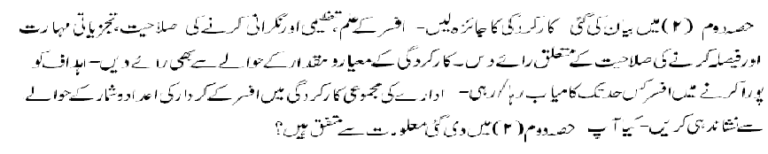

 |  | A | B | C | D
1 | Quality of work  Always produce work of exceptionally high Quality |  |  |  |  | Generally produces work of poor quality.
2 | Output of work  Always up-to-date; accumulates no arrears |  |  |  |  | Always behind schedule; very slow disposal.

2. Integrity (Morality, uprightness and honesty)

 |  | A | B | C | D
1. | Integrity  - General  Irreproachable |  |  |  |  | Unscrupulous
 | - Intellectual  Honest & straightforward |  |  |  |  | Devious; Sycophant

3. Pen picture including the officer's strengths and weaknesses with focus on emotional stability, ability to work under pressure, communication skills and interpersonal effectiveness. (Weakness will not be considered as adverse entry unless intended to be treated as adverse). 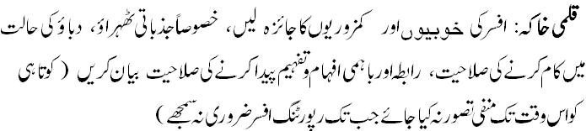

4. Area and level of professional expertise with suggessions for future posting.

5. Training and development needs.

6. Overall grading

7. Fitness for promotion Comment on the officer's potential for holding a higher
position and additional responsibilities.

Name of the reporting officer Signature
(Capital letters)

Designation Date
PART IV
(REMARKS OF THE COUNTERSIGNING OFFICER)

1. How often have you seen the work of the officer reported upon?

Very frequently | Frequently | Rarely | Never

2. How well do you know the officer? If you disagree with the assessment of
the reporting officer, please give reasons.

3. Overall grading

4. Recommendation for promotion (Comment on the officer's potential for holding a
higher position and additional responsibilities).

5. Evaluation of the quality of assessment made by the reporting officer.

Exaggerated |  | Fair |  | Biased

Name of the countersigning officer Signature
(Capital letters)

Designation Date

PART V
REMARKS OF THE SECOND COUNTERSIGNING OFFICER (IF ANY)

Name Signature

Designation Date

